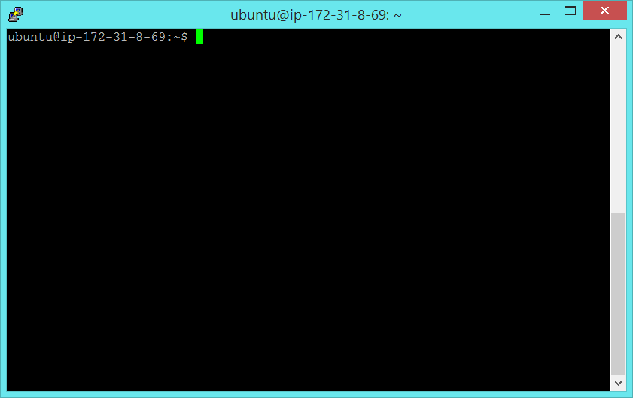

export AWS_ACCESS_KEY_ID=<ACCESS_KEY_ID>

export AWS_SECRET_ACCESS_KEY=<SECRET_ACCESS_KEY>

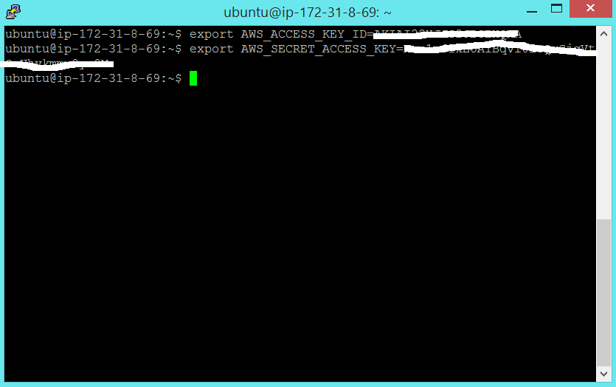

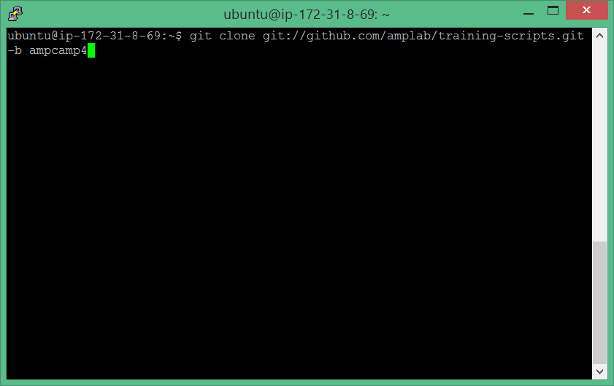

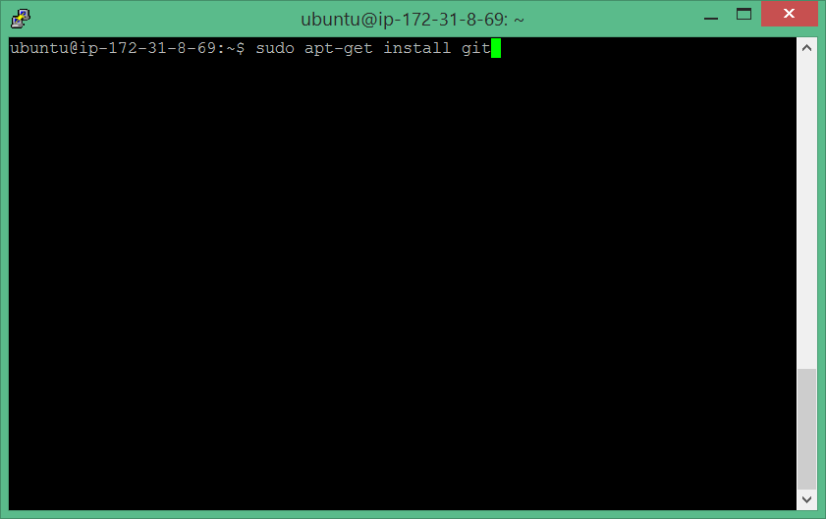

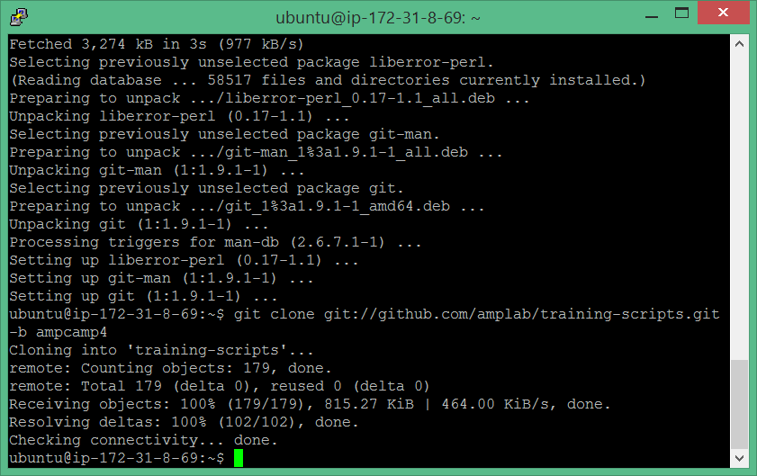

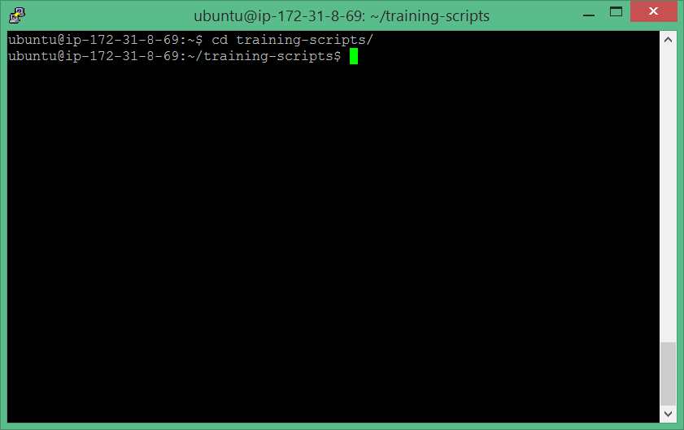

Downlaod and install <http://winscp.net/eng/download.php>

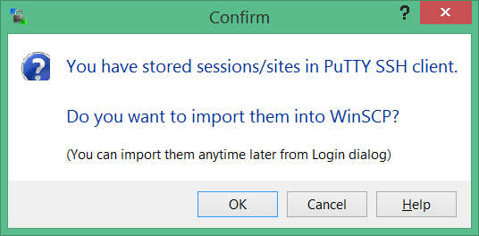

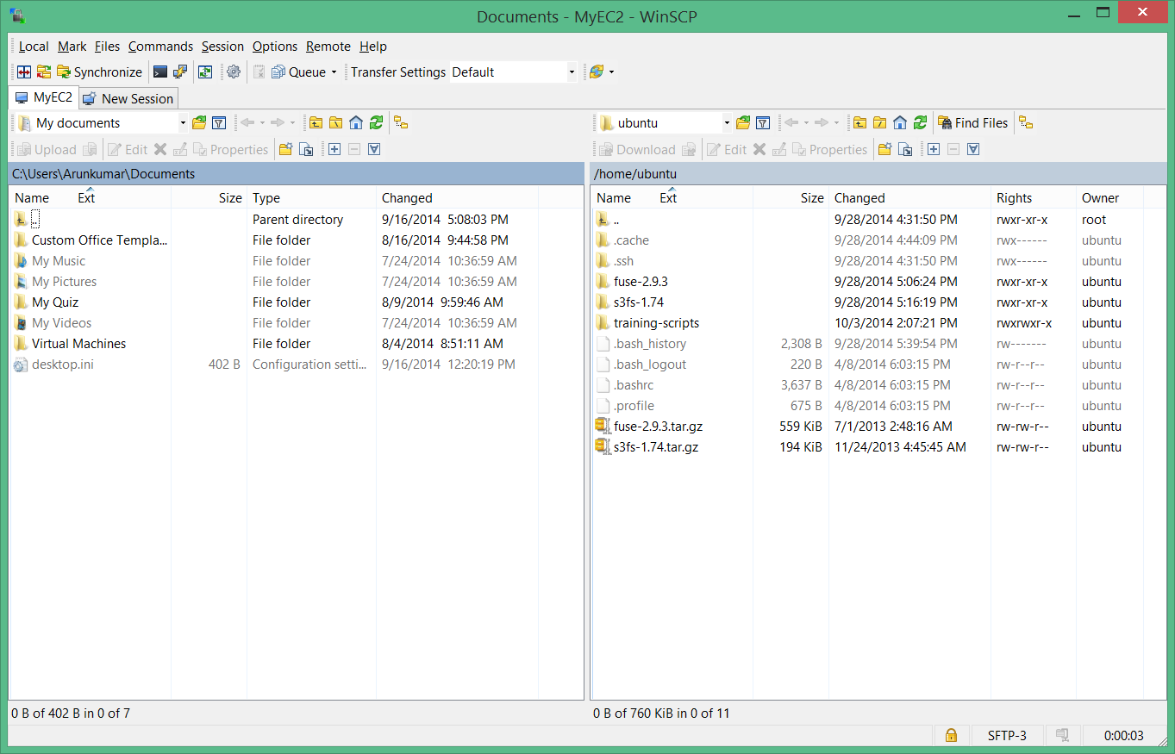

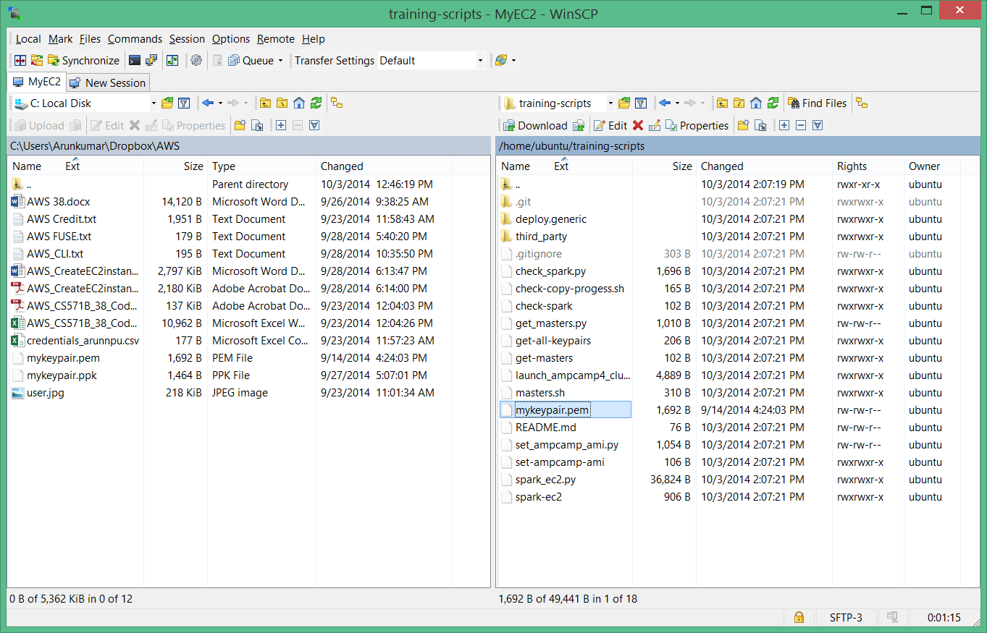

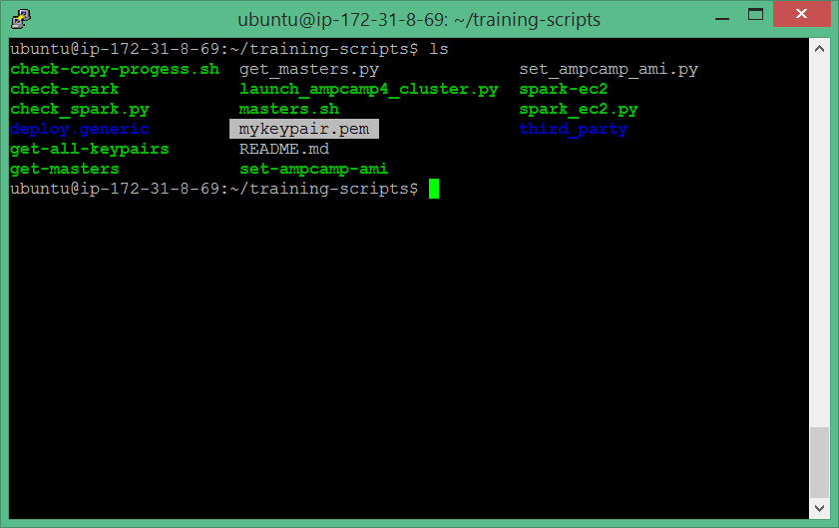

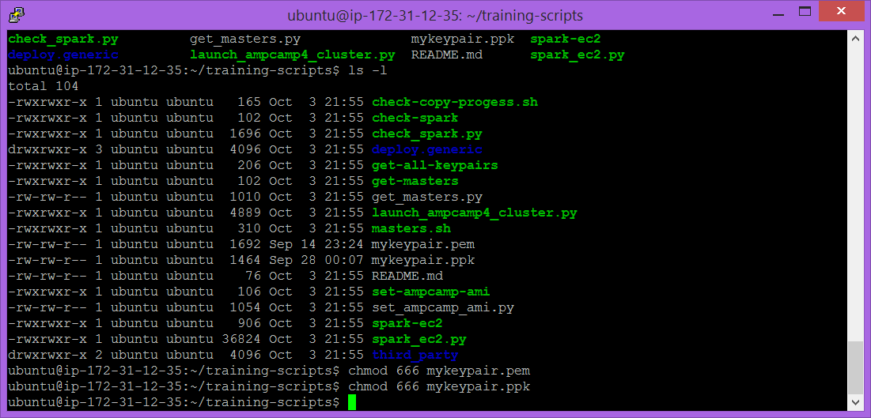

./spark-ec2 -i mykeypair.pem -k mykeypair -r us-west-1 -a ami-6ac4ee2f --copy launch amplab-training

**Question: Can I use a EC2 region other than us-east-1 while creating the cluster?**

**Answer:** These exercises have been created and tested on the us-east-1 region. However we have also copied the AMI to the us-west-1 region as well. To use the us-west-1 region, you can run the following command:

./spark-ec2 -i <key_file> -k <name_of_key_pair> -r us-west-1 -a ami-6ac4ee2f --copy launch amplab-training

We do not support running the AMI in any other EC2 regions. In case you need to do so, feel free to contact us for more help.

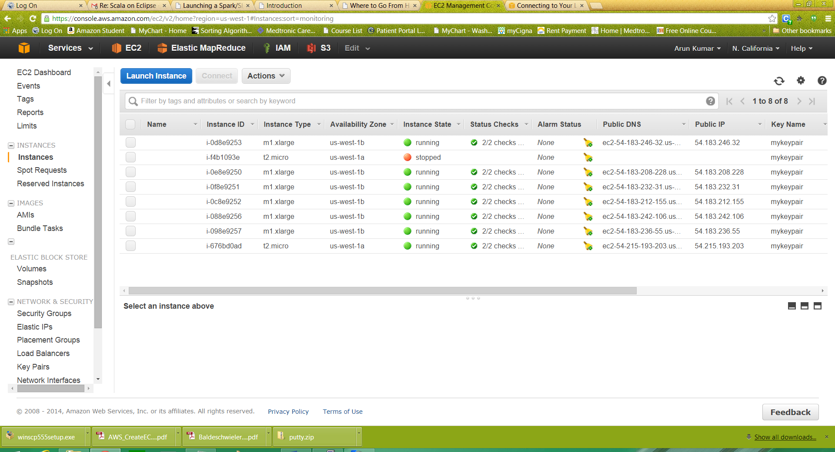

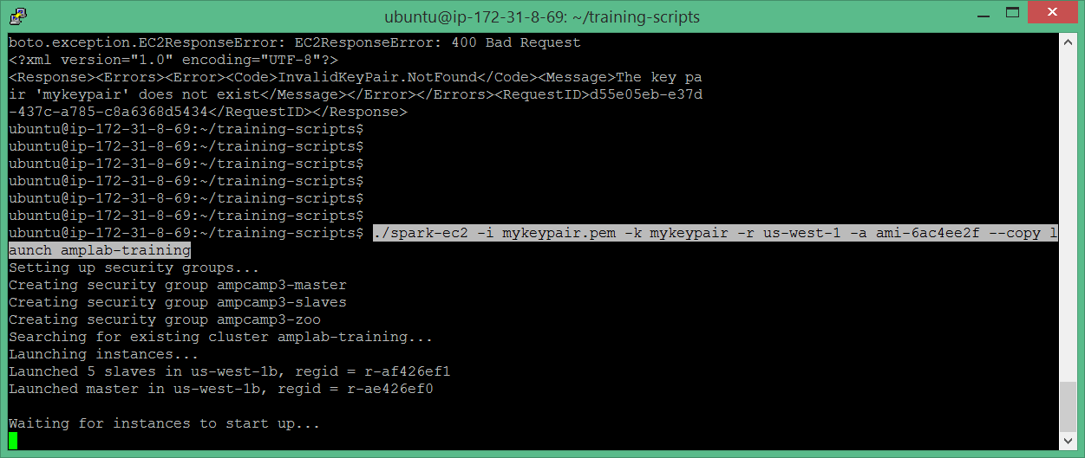

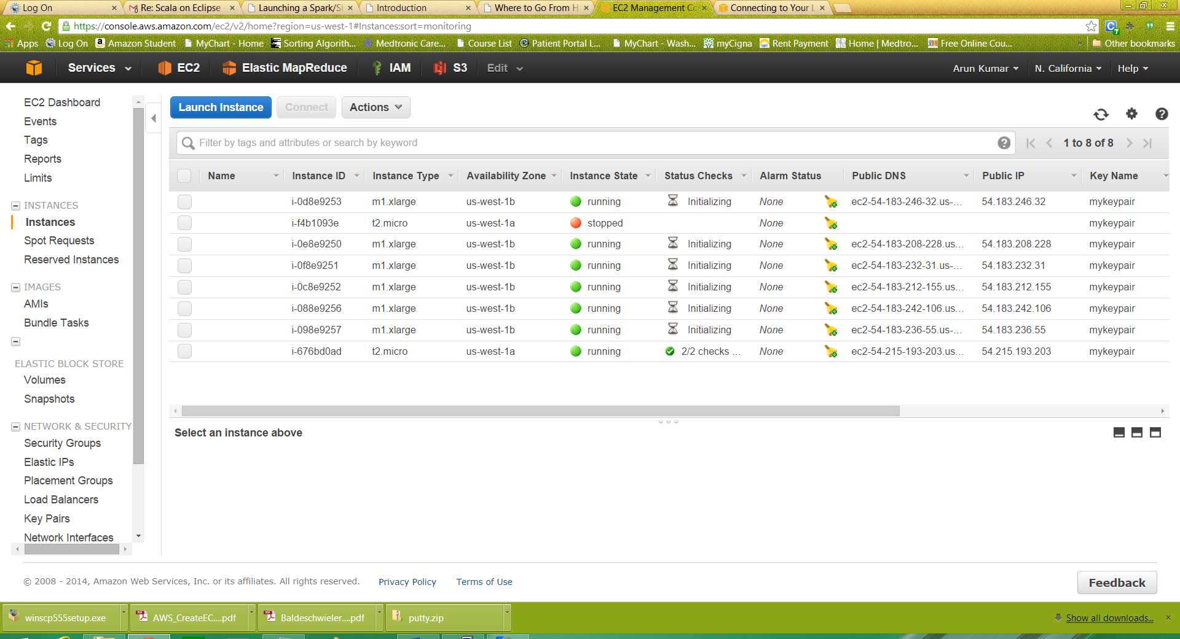

./spark-ec2 -i mykeypair.pem -k mykeypair destroy amplab-training

